

**Project Documentation and Instructions**

**University of Balamand**

**Faculty of Sciences**

**Department of Computer Sciences**

**Advances In Computer Science CSIS-2**

By David Kharrat

**MARKET MANAGER**

# Project Documentation

Version 1.0

Client: Dr. Charbel

11/18/2024

*The current project is copyrighted by David Kharrat:*

*-This PDF File being the Project Documentation and Instructions of the project*

*-A zipped file containing:*

*--api: project backend*

*--app: project frontend*

Table of Contents

1. Introduction

1.1 Purpose, Project Description

1.2 Key Features

1.3 UI Prototype

2. Technologies Used

2.1 Front End Technologies

2.2 Back End Technologies

3. Project Timeline

## Introduction

This Project Proposal offers a concise overview of the project's purpose, outlining its core structure, initial concept, and key objectives.

### Purpose, Project Description:

The purpose of this project is to deliver a product that will manage Instagram, Facebook, tiktok (And potentially other platform’s) Ads, while also creating a website that displays all the desired information of the user (And potentially create a way for users to create e-commerce and other types of advanced websites).

The project’s main targets are small to medium businesses that don’t have a strong online presence and may be inexperienced in this domain. The project will create a reliable and easy to use interface that will let these small buisnesses manage their online presence with a few clicks (the project could also potentially automate all posts with ai using only input text and images).

This type of service is scarce in the Middle East and Asian markets, this project’s main goal will be to appeal to that demographic.

### Key Features:

**The Project will work as such:**

**INPUT TAKEN:**

company information, images, preferred style, preferred marketing package(which platforms to market in, how much to pay, which premium features to use)

**OUTPUT GIVEN:**

Robust Website design, reliable marketing manager with posts posting constantly ( with approval of the company before posting)

No major competitors in the middle east and Asian regions, the software must appeal to this demography having easy to access and use features for older users. This will guarantee the software’s success.

### UI :

**The Project is still in a prototype state ad will be updated for the final of the course**

**1-Interactive Cover/Front Page:**

This well designed page, welcomes the user to the application, here , the user can navigate to the login, to login into the website, signup , if he doesn’t have an account, and get started, to learn more about the website, this design is just a prototype, and will be updated to make it more user friendly



**2-Sign Up/ Login Page:**

For user to sign Up and Login to the application

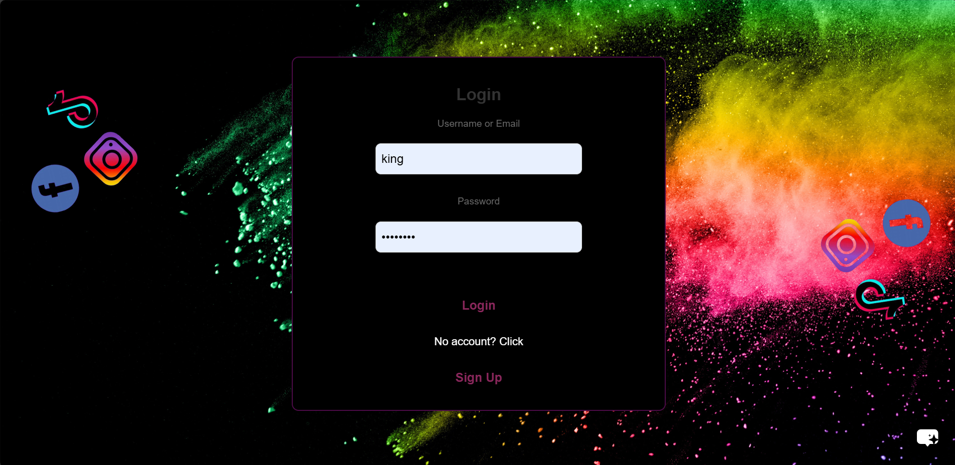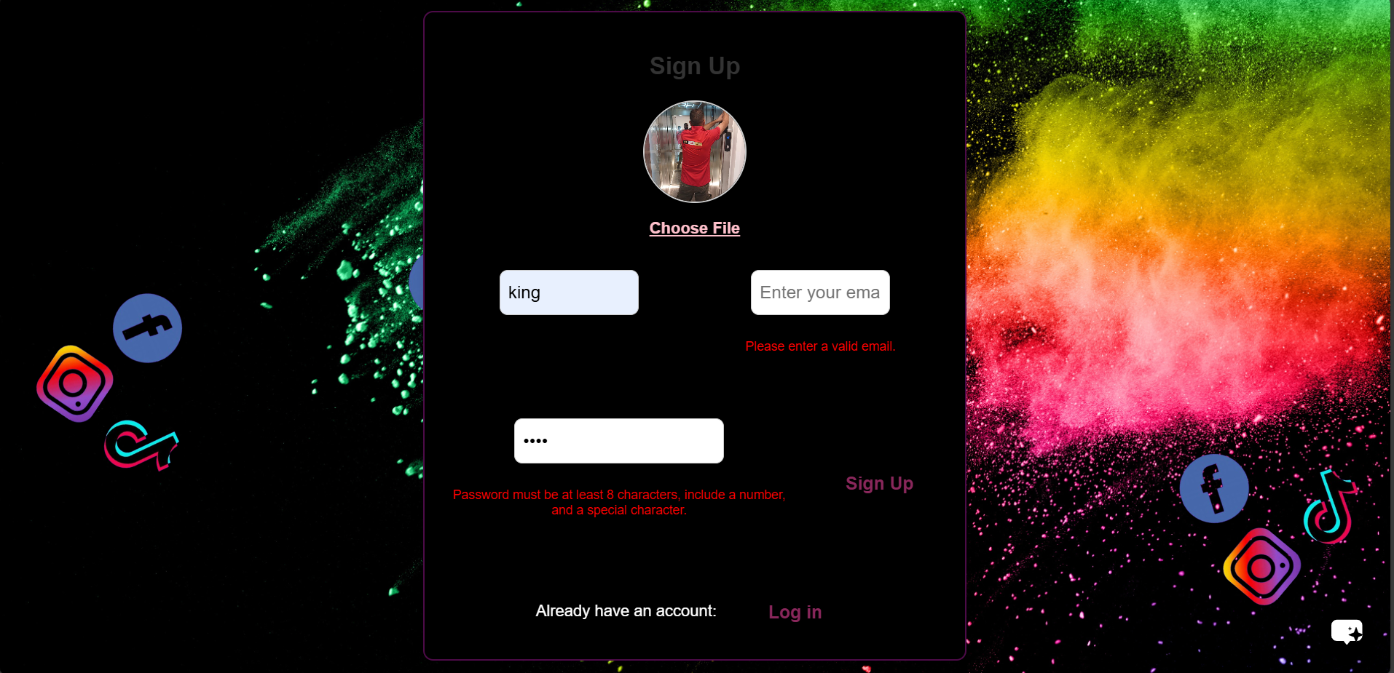

**3-Welcome Page:**

Interactive Welcoming page for the user to learn more about the website





**4-Subscription Page:**

After the user’s first login, if the user isn’t subscribed to a subscription, this page appears, the user subscribes to a package and gets to use said package’s privileges

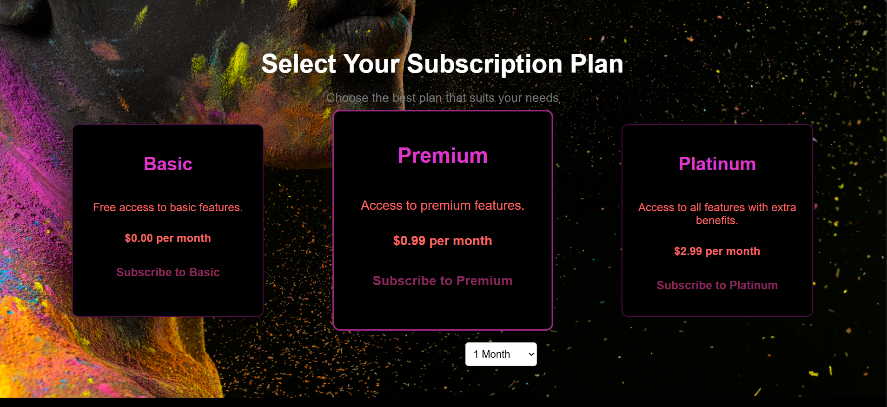

**5-Main Workplace Page:**

After the user Login, and after the user chose their appropriate package, they get to this workplace, by default to this main tab of the workplace.

This contains a detailed guide of the tools that can be used by the user, and a brief introduction for those tools

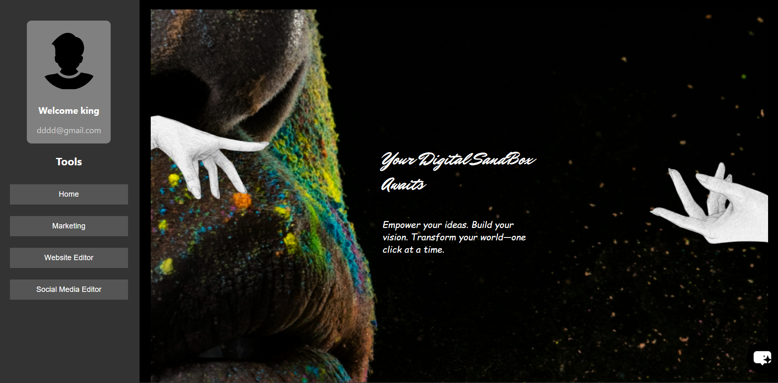

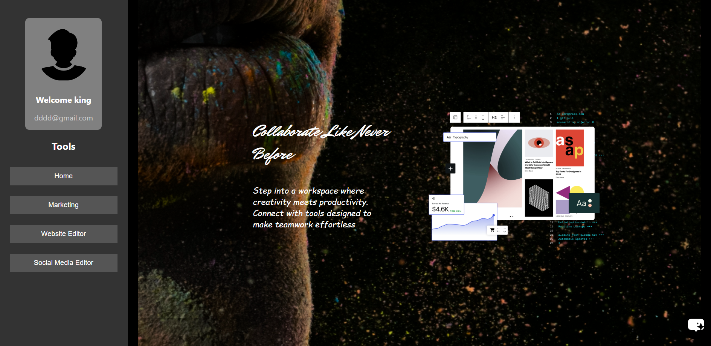

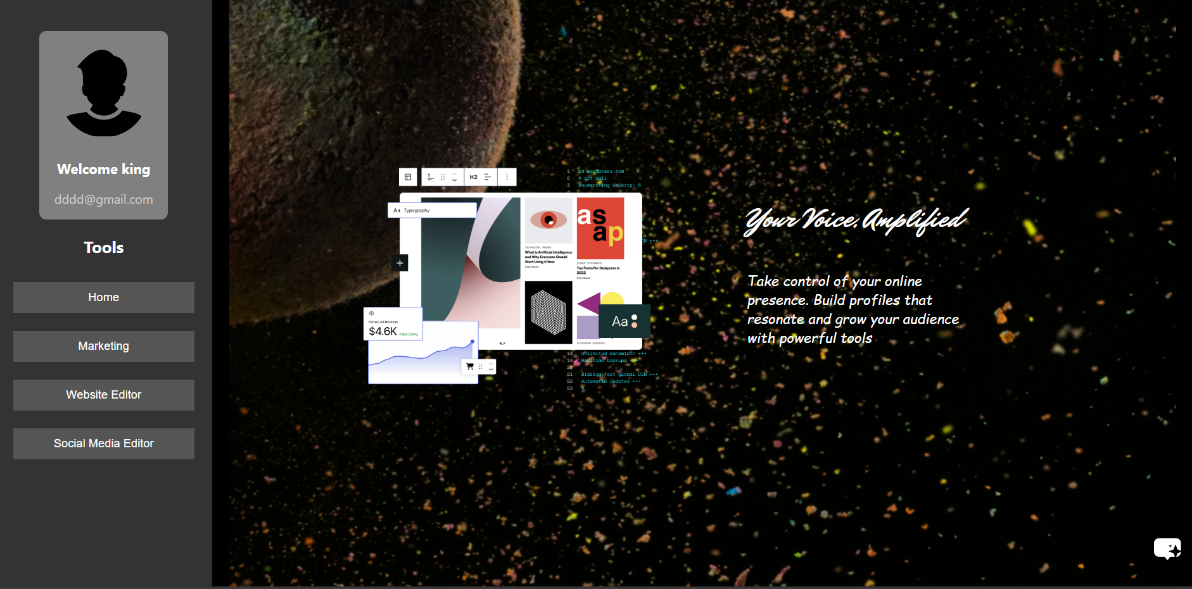

**6-Social Media Editor:**

This is a prototype( I provided two but this one is the one that uses the backend api to create the posts)

In this page, the user can add posts and delete them. Each user has his own posts that only they can access.

This is a very primitive implementation of the Manage posts

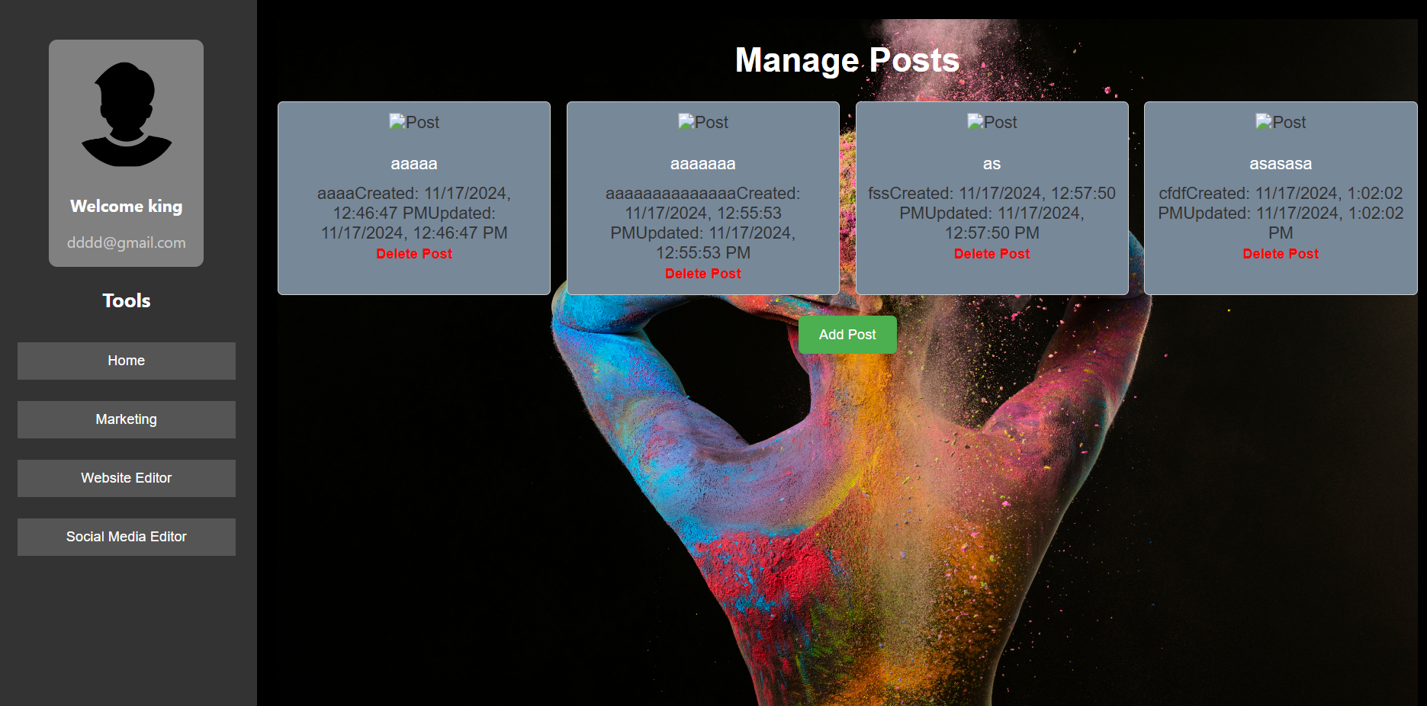

The desired outcome will look somewhat like this other prototype:

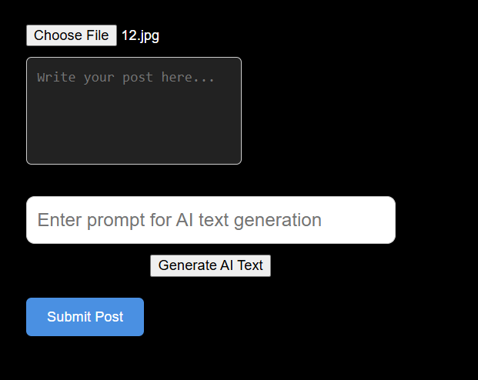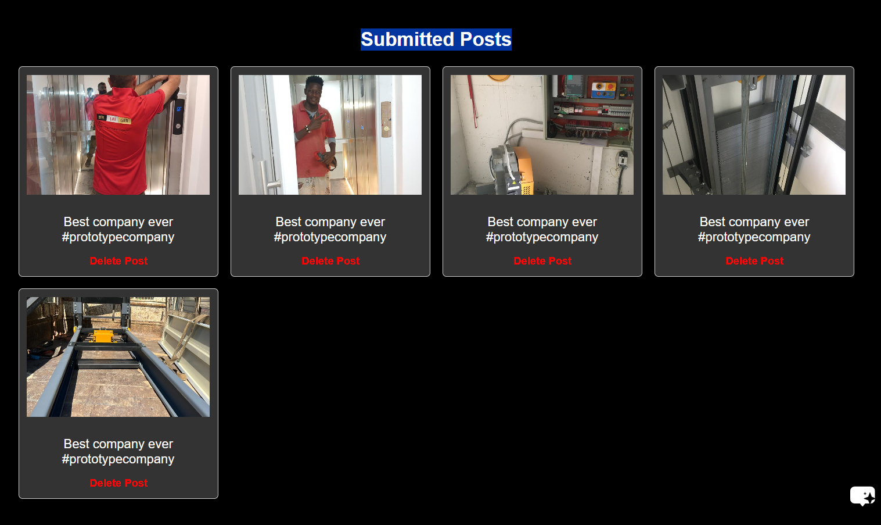

**7-Website Editor:**

This is a prototype of how the website editor will look. It is currently not connected to the backend, but will be, with further optimizations for the final:

Here we can make a background that is either a color or an image, we can add images, and there is multiple layout types for the website. This section is just a prototype and will be redesigned from the ground up in another fashion.

Instead of this implementation,

There will be a grid like structure(Similar to applications like Figma) where the user can drag and drop components wherever they want, there will also be templates that the user can choose from to facilitate his designing process.



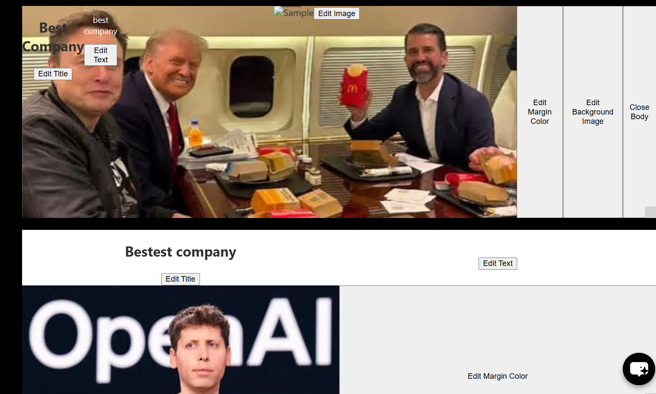

## Technologies used

This project aims to provide an easy-to-use platform for small to medium businesses in the Middle East and Asia to establish and manage their online presence. The Technologies that will be used must be easy to manage, efficient and with a low cost.

**1.Frontend Technologies**

**1. Frameworks/Libraries:**

- React.js : For building a dynamic and responsive user interface.

- CSS: For styling and creating a responsive layout.

**2. State Management:**

- Redux or Vuex: For managing application state and ensuring smooth data flow.

**3. Forms Handling:**

- React Hook Form: For easy management of user input and validation.

**4. API Interaction:**

- Axios: For making HTTP requests to the backend.

**2.Backend Technologies**

**1. Frameworks:**

- Node.js with Express: For building a RESTful API that handles requests and serves data.

- Django or Flask (Python): As an alternative for rapid development and strong database integration.

**2. Database:**

- MongoDB: A NoSQL database for flexible data storage, suitable for user profiles and website content.

**3. Authentication:**

- JWT (JSON Web Tokens): For user authentication and maintaining session state.

**5. AI and Automation:**

- OpenAI API or similar: For generating content and automating posts based on user input.

**3. APIs and Integrations:**

**- Payment Processing:**

- Stripe or PayPal: For managing transactions, especially if users opt for premium features.

**- Social Media APIs:**

- Facebook Graph API, Instagram Graph API, Twitter API: For automating posts and managing social media marketing.

**3. Email Marketing:**

- Mailchimp or SendGrid: For managing email campaigns and newsletters.

**4. Analytics:**

- Google Analytics API: For tracking user engagement and performance of websites.

**3.Expected challenges:**

The main challenge will be creating the application for it to be reliable and easy to use.

This will require a lot of skills that I will have to learn, like how to integrate Ai into the software, how to automate the process of making posts on social media, how to make an easy to use website and post maker that uses AI and could potentially be fully automated with a few clicks.

This project will be a challenging one, which will take a lot of time, dedication and learning, but I believe that this goal is achievable and I believe in it being Final Project worthy.

# User Manual

## Introduction

This user manual provides a comprehensive guide on how to use Postman, set up backend and frontend, test APIs, and troubleshoot. It includes templates for JSON objects and step-by-step instructions.

## 2 Setting up Backend and Frontend

### Backend Setup

1. Install Node.js and npm if not already installed.

2. Clone the backend repository from your version control system.

3. Run `npm install` to install dependencies.

4. Start the server using `npm start` or `node server.js`.

### Frontend Setup

1. Clone the frontend repository.

2. Run `npm install` to install frontend dependencies.

3. Start the frontend using `npm start`. Ensure the backend server is running.

## Using Postman

Postman is used to test APIs and interact with backend routes.

### Steps to Test Backend Routes

1. Open Postman and create a new request.

2. Choose the request type (GET, POST, PUT, DELETE).

3. Enter the API endpoint (e.g., `http://localhost:3000/api/posts`).

4. Provide the required headers (e.g., Authorization, Content-Type).

5. Add JSON body for POST or PUT requests.

6. Click 'Send' and inspect the response.

### Example JSON Templates

User Registration:

{  
 "username": "johndoe",  
 "email": "johndoe@example.com",  
 "password": "securepassword"  
}

Post Creation:

{  
 "title": "My Post",  
 "content": "This is a sample post content.",  
 "image": "base64_encoded_image_string"  
}

If an authentication is required, after user login, a token is created which should be used( placed in the header in postman(backend), automatically used in the frontend) for authentication

## Backend Routes

### Posts API

GET /api/posts - Retrieve all posts

POST /api/posts - Create a new post (requires authentication)

GET /api/posts/user - Retrieve posts by a specific user (requires authentication)

DELETE /api/posts/:id - Delete a post by ID (requires authentication)

### Subscription Packages API

GET /api/subscriptions - Retrieve all subscription packages

POST /api/subscriptions - Create a new subscription package

### Users API

GET /api/users - Retrieve all users

POST /api/users - Register a new user

POST /api/users/login - Login as a user

GET /api/users/:id - Retrieve a user by ID (requires authentication)

DELETE /api/users/:id - Delete a user by ID (requires authentication)

PUT /api/users/:id - Update user details (requires authentication)

### Websites API

GET /api/websites - Retrieve all websites

POST /api/websites - Create a new website

### Website Sections API

GET /api/sections - Retrieve all sections

POST /api/sections - Create a new section

PUT /api/sections/:id - Update a section by ID

DELETE /api/sections/:id - Delete a section by ID